|  |
| --- |
| **DUB IT RIGHT** |

Use this template to prepare your dialogues:

SCRIPT 1.

Principal Character:

Person 1:

PC: ?

P1:

PC: ?

P1. !

PC:

P1:

SCRIPT 2.

Principal Character:

Person 1: ?

PC: ?

P1:

PC:

P1:

PC:

SCRIPT 3.

Principal Character:

Person 1: ?

PC:

P1:

PC:

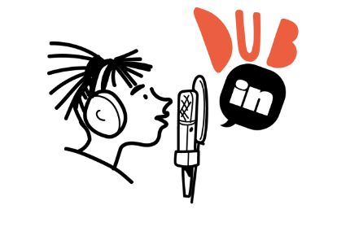P1:

PC:

P1:

PC: